**Exp. 4**

**Design a smart phone controlled light system**

Circuit Diagram:

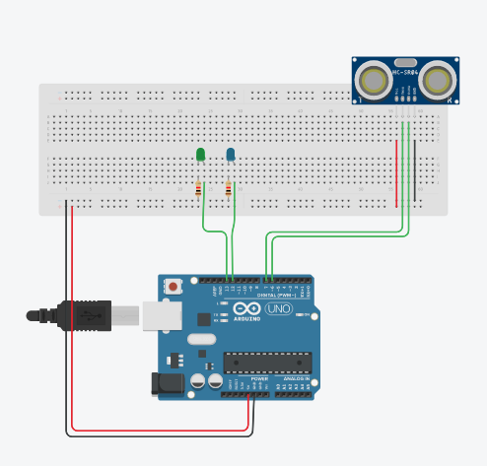

**Code**

#define trigPin 7

#define echoPin 6

#define led 13

#define led2 12

void setup() {

Serial.begin (9600);

pinMode(trigPin, OUTPUT);

pinMode(echoPin, INPUT);

pinMode(led, OUTPUT);

pinMode(led2, OUTPUT);

}

void loop() {

long duration, distance;

digitalWrite(trigPin, LOW);

delayMicroseconds(2);

digitalWrite(trigPin, HIGH);

delayMicroseconds(10);

digitalWrite(trigPin, LOW);

duration = pulseIn(echoPin, HIGH);

distance = (duration/2) / 29.1;

if (distance >= 30) {

digitalWrite(led, HIGH);

}

else {

digitalWrite(led,LOW);

}

if (distance < 29) {

digitalWrite(led2, HIGH);

}

else {

digitalWrite(led2, LOW);

}

if (distance > 30 || distance <= 0){

Serial.println("Out of range");

}

else {

Serial.print(distance);

Serial.println(" cm");

}

delay(500);

}

**Theory**

Concepts Used:

1. Working of Arduino UNO , LEDs, Ultrasonic Sensors.
2. Circuitry of Breadboard.
3. Coding in Arduino IDE and syntax of the same.
4. Sending pulse signal through trigger mechanism concept.

Learning & Observations:

Coding in Arduino IDE:

Coding syntax is very similar to the coding in C language which we are being taught, hence easy to use and work with.

I would use the following module in all the units.

Also if I some places in the box remain undetectable, I would use multiple modules in each cabinet covering it thoroughly.

The condition would be then modified to

If**(** any one module detects any change than the originally obtained values**)**

Problems & Troubleshooting

I encountered the following issues in solving the problem :

1. I found no way to show a box like structure in tinkercad,

Thus I drew a line box to represent a ***virtual box***.

The solution I have provided will work with real boundries in place of the lines.

1. I at first attempted to gain the boundry pulse time or distance by using pulse trigger code and pulseIn() function in the setup() loop,

Which didn’t work for me and thus,

I introduced a variable initialized with 1 and incremented it at right place to gain desired results.

1. Because this is ideal situation in tinkercad, I haven’t introduced the connection of pin 12 to ground through High resistance. As there are no outer electromagnetic induction in tinkercad.
2. I had the following Circuit in mind so that nothing escapes the sensors in the box but due to unfamiliarity with tinkercad and limitations of tinkercad, I had to change towards the current circuit.
3. I tried to use pulseIn() function inside if statement’s condition and it didn’t give me required results thus I used it before if statement.

Precautions

1. Remember to declare the scopes of various conditional statements right or tangled results will be observed (Difficult to debug).
2. Remember: It’s a case sensitive language.
3. Remember that at the beginning the box is supposed to be empty so that the sensor can judge the empty box and thus differenciate it with one something in it.

Learning Outcomes

1. I learnt how to make the sensor work in bounding parameters.
2. I learnt that the sensors of infinite number of applications.
3. I learned how to use ultrasonic sensor and timer functions.
4. I learned that doing things by hand are sometimes more easier and better than to do the same on limited actions software or website such as Tinkercad.